The “Drama lesson”
done by T.Tymchenko
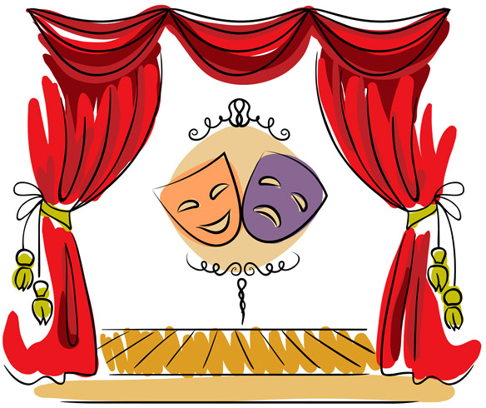

Acquaintance
- The motto – “Learn English with mind, heart and body”.
- Remember!!!!: AFFECTIVE IS EFFECTIVE (The more emotions the better)
Your body, your gestures, your facial expression speak first and only after that your tongue speaks.
- Let’s greet each other and get acquainted.
- Move around the room, shake hands, say “Good morning, I am (your name)”
(Don’t forget to express joy and to smile)
APPLAUSE
- Think of a gesture to introduce yourself. Use it and say:
“Hello. My name is (your name)”
(Speak loudly and distinctly)
APPLAUSE
- Work in moving columns

Ask each other “Where are you from?” – Nizhyn. Nizhyn? Nizhyn. (Change the intonation)

Warm up
- A ritual at the beginning of work
Say “a, e, i, o, u, y” beating your chest with your fist.
APPLAUSE
- Let’s warm up our bodies.
(to the music)
Move chaotically around the room the way I tell you: as if you were a fox, a hare, a cat, a bear, a frog.
(The teacher says: Move! Stop! Move! Stop! )
APPLAUSE
- Move according to the situation
(Recordings of some sounds are used: rain; the railway station)
You are in the park on a hot sunny day; sudden rain; you are at the railway station, trying to catch your train at the last minute; you are squeezing through a thick crowd of people to the exit; you try to get into your own room so that no one in your family hear you or see you (because you are returning very late).
APPLAUSE
Exercises for bodies and facial expression
- Pantomime
Stand in a circle. Imagine that you are taking from me what I am giving you (show your emotions):
- a delicate flower
- a frog
- a chewing gum
APPLAUSE
- Accusation
(with a ball)
Imagine that somebody accuses you of something. Express your indignation, saying: “Me? No. You.” And through the ball to somebody else. Pronounce everything loudly and distinctly.
APPLAUSE
- Soap bubbles
You see many soap bubble. Catch them and break them with your finger, saying: “[p]” (“[t]”/”[k]”). Show your emotions.
APPLAUSE
- Show pleasure. Enjoyment.
You see a table full of various delicious things on it. Help yourself to anything you like and express your enjoyment. You may use some words: (Oh, chocolate! Yum! Mmm! Oh! Ah! etc)
APPLAUSE
Exercises for voice, articulation and intonation

- Tongue twisters
“Betty Botter”
(Each participant gets a card)

“Betty Botter bought some butter
But she said this butter's bitter
But a bit of better butter
Will make my bitter butter better”.

Warning: Don’t use any context here!!!

Practice separate words (short-long vowels)

Pronounce everything very slowly than quicker and quicker (“A Train”)

Practice the whole rhyme and read it in the best and quickest way
APPLAUSE

- Practicing information
Tongue twister: “Oh, no, don't go home alone. Nobody knows how lonely the road is”
Look at the pictures showing different emotions and read the phrase with the given emotion.
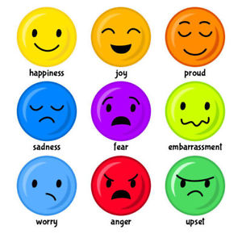
- Emotions and Intonation
(cards)
Each participant gets a card with a profession or occupation written on it. (For example: a sport commentator, a TV announcer, a strict parent, a teacher, a general, a 3 year-old child etc)
Read the rhyme: Rain” as if you were that person.
Rain, rain, go away.
Come again another day.
Little Tommy wants to play.
(The others try to guess the character)
APPLAUSE
- “Number Talk”
(cards)
All the participants are split into groups of 3 or 4.
Each group gets a card with a situation (a problem) to discuss. Try to discuss it emotionally, but instead of words, use numbers from 1 to 100.
Be:
- Calm
- Emotionally
- Angrily
(The others guess what they are arguing about and whether they have or haven’t come to any conclusion.)
APPLAUSE
Dramatizing
- “Stiff (frozen) Figures
Split into groups of 3 or 4. Each group is given the task (a situation to be shown)
E.g: a broken vase; winning the match etc)
The leader make up a statue (a group monument). The rest – guess the theme and the idea. The emotions and facial expression are important.
- Dramatize a little tale or story. (Group of 5-6)
E.g: “A little mouse and a big lion”. “A little round bun” etc.
- Summing up
Reflexion.

